

Pilot Study Equipment Installation
Author: Seán McMahon
Department: Engineering
Contributors: Steen Gordon
Security Warning: These Technical Data and the Designs disclosed herein are the exclusive property of WaveScope or contain proprietary rights of others and are not to be used or disclosed to others without the written consent of WaveScope. The recipient of this document by its retention and use agrees to respect the Security Status of the Technical Data and Designs contained herein. The foregoing shall not apply to persons having Proprietary Rights to such Technical data or such Designs to the extent that such Rights exist.
© Copyright
This document is the property of WaveScope who own the copyright therein. The information in this document is given in confidence and without the written consent of WaveScope given by contract or otherwise the document must not be copied reprinted or reproduced in any material form either wholly or in part nor must the contents of the document or any method or technique available therefrom be disclosed to any third party.
WaveScope Ltd.
25 Inchicore Terrace South, Inchicore, Dublin 8, Ireland
www.wavescopeai.com

Data Item Description

Revision History

Version | Status | Date | Author | Change Description
0.1 | Draft | 13/06/2024 | S McMahon | Initial draft
1.0 | Release

Purpose
This document is intended to detail the equipment installation needed for the pilot study.

Stakeholders

Stakeholder should indicate their approval.
Position | Name | Date
Engineering Director | Sean McMahon | 13/06/2024
Commercial Director | Steen Gordon

Contents
1 Data Item Description 2
1.1 Revision History 2
1.2 Purpose 2
1.3 Stakeholders 2
2 Introduction 4
3 Raspberry Pi 5 OS Installation 5
4 Windows 10 Python Installation 8
5 References 10

Introduction
The pilot study will a procedure described in the pilot study document and illustrated below.

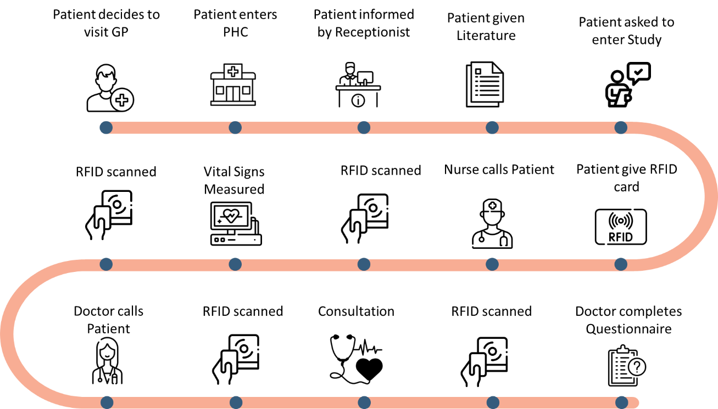
Figure 1 Pilot Study Procedure

The following list summarises the main technological requirements for the pilot study.

- Timing
- Vital Signs Assessment Communication to Doctor

Raspberry Pi 5 OS Installation
Place SD card in Kingstone SD card adapter and insert into MSI GE63VR

Go to https://www.raspberrypi.com/software/

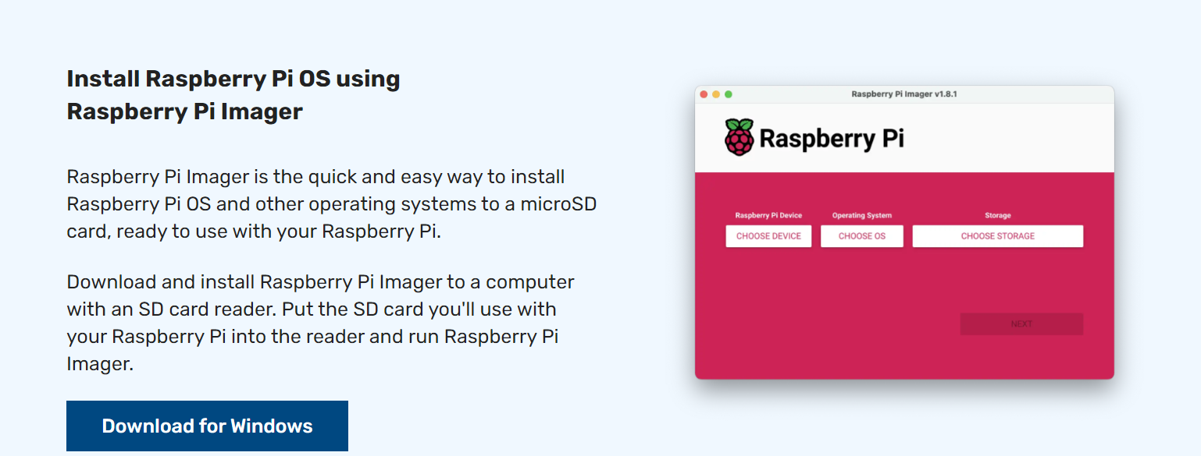

Click Download for windows and save imager_1.8.5

Open application
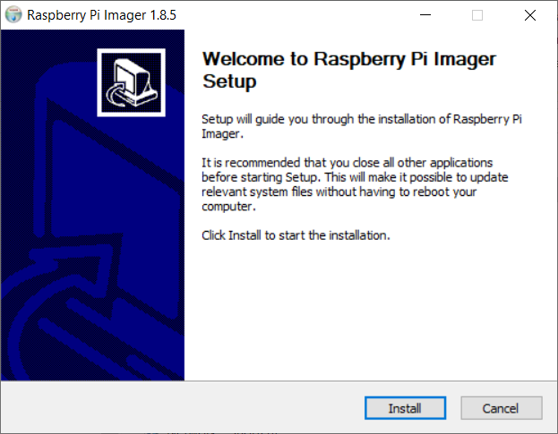

Click install
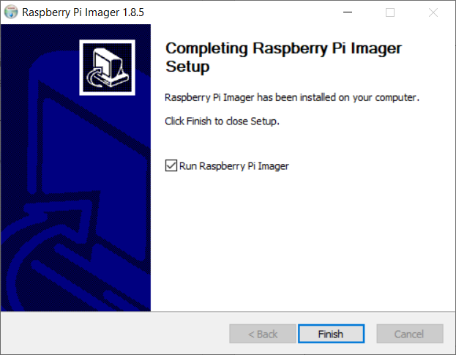
Click Finish

Windows 10 Python Installation
Got to https://www.python.org/downloads/

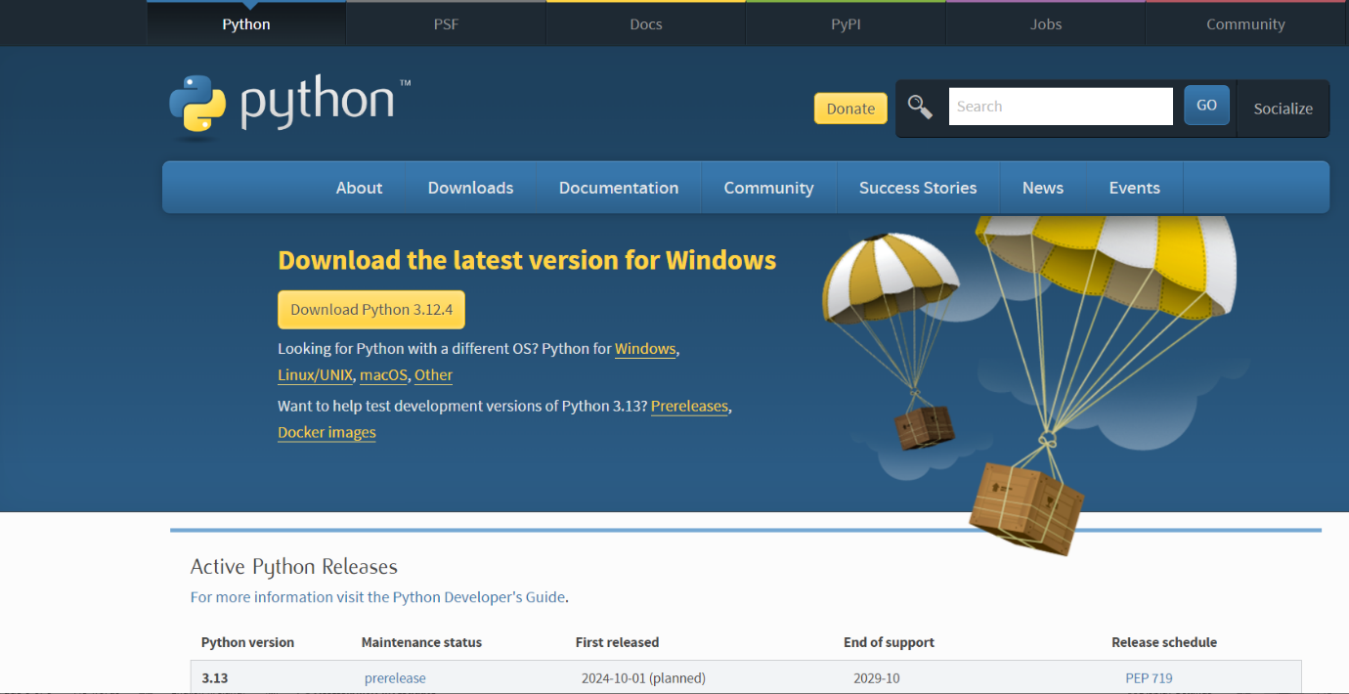

Choose the latest version of python 3.11 e.g. https://www.python.org/downloads/release/python-3119/

Download and install.

Once installed type cmd and open as administrator.

Type the following commands:

pip install pyscard
pip install pillow
pip install tkinter
Create a directory called C:\pilot
Copy the pilot study code to this folder.
Execute the batch file via the shortcut
pilot - Shortcut

ACS Driver Installation

Go to
https://www.acs.com.hk/en/driver/169/acr1222l-visualvantage-usb-nfc-reader-with-lcd/
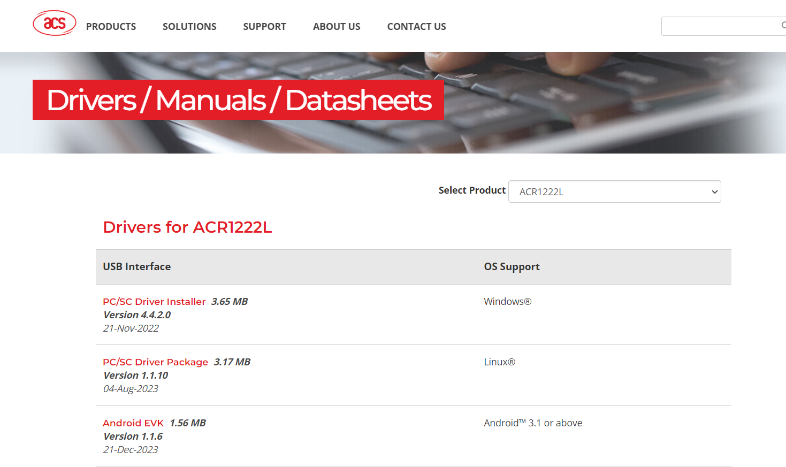

Download the Windows 10 driver.

References
There are no sources in the current document.

